Assignment 4

Prashanna Acharya
Computer Architecture and Design (MSCS-531-A01)
University of the Cumberlands
Dr. Vanessa Cooper

Github Link: https://github.com/prashcodes10/MSCS531_Assignment4
Part 1
Instruction-Level Parallelism in Modern Processors
Introduction
Instruction-Level Parallelism (ILP) describes the extent, to which a processor can execute multiple instructions at the same time within a single instruction stream. For many years, ILP has been one of the main drivers of performance improvement in microprocessor design. By overlapping instruction execution, architects were able to deliver faster processors without relying solely on higher clock speeds. Techniques such as pipelining, superscalar execution, and out-of-order processing became central to modern CPUs.
In recent years, however, the limits of this approach have become increasingly clear. Power constraints, growing hardware complexity, and even security concerns now shape processor design as much as raw performance does. As a result, researchers are re-evaluating how ILP should be exploited going forward. This review looks at how ILP has evolved over time, explains its key ideas and limitations, discusses the challenges faced by modern processors, and highlights promising directions emerging from recent research.
Evolution of Instruction-Level Parallelism
The story of ILP begins with early pipelined processors, where instruction execution was broken into stages that could operate in parallel. This simple idea allowed processors to complete more instructions per unit time without fundamentally changing program behavior. RISC architecture in the 1980s built on this concept by using simpler instructions and predictable execution patterns, which made both hardware design and compiler scheduling more effective.
As applications became more complex, static scheduling alone was no longer enough. Superscalar processors emerged, which were capable of issuing multiple instructions in a single clock cycle. Dynamic scheduling techniques allowed processors to analyze dependencies at runtime, executing independent instructions out of order when possible. Register renaming played a crucial role by removing artificial dependencies, further increasing available parallelism.
By the late 1990s, processors were aggressively exploiting ILP through out-of-order and speculative execution. Sophisticated branch predictors enabled execution far ahead of the current program point, while large instruction windows searched for parallel work. These designs delivered impressive performance gains, but they also introduced significant costs in terms of power consumption and design complexity. Over time, it became clear that simply scaling these techniques was no longer sustainable, leading to a gradual shift toward multicore and heterogeneous architectures.
Core Concepts and Practical Limits of ILP
Modern processors extract ILP primarily through dynamic, hardware-based mechanisms. At any given time, the processor examines a window of in-flight instructions, checking for data and control dependencies. Instructions whose operands are ready can be dispatched to execution units immediately, even if earlier instructions are still waiting. Speculative execution helps hide control dependencies by predicting future execution paths and continuing work before outcomes are known.
Despite these capabilities, ILP is fundamentally limited by the structure of programs themselves. True data dependencies cannot be eliminated and force instructions to execute in sequence. Branch-heavy code restricts speculation, especially when predictions are inaccurate. Memory operations introduce additional uncertainty, as cache misses and unknown aliasing relationships can stall execution. These factors mean that real programs often expose far less parallelism than theoretical models suggest.
Measuring the effectiveness of ILP typically involves metrics such as instructions per cycle (IPC), which captures how much work a processor completes each cycle. However, IPC alone provides an incomplete picture. Modern research increasingly considers power consumption, energy efficiency, and hardware cost. In many cases, modest IPC gains come at the expense of disproportionately higher power usage, reinforcing the need for balanced design decisions.
Challenges in Contemporary ILP Design
One of the most pressing challenges for ILP today is the problem of diminishing returns. Studies of modern workloads consistently show that widening issue widths or expanding instruction windows yields smaller performance improvements than in the past. Meanwhile, the associated hardware structures grow larger, more power-hungry, and harder to manage.
Power and thermal constraints have become especially important in both mobile devices and large-scale data centers. Aggressive ILP techniques rely on complex scheduling logic and large buffers, which consume energy even when parallelism is limited. At the same time, verifying and maintaining such complex hardware designs increases development cost and risk.
Security has added another layer of difficulty. The discovery of speculative execution vulnerabilities demonstrated that techniques designed purely for performance could introduce serious side effects. As a result, architects must now carefully limit or redesign speculation mechanisms, often trading some performance for improved security guarantees.
How Current Research Is Responding
Recent research reflects a shift toward more thoughtful and adaptive approaches to ILP. One promising direction involves using machine learning techniques to guide scheduling and speculation decisions. Rather than relying on fixed heuristics, these systems learn from program behavior and adjust dynamically, potentially improving efficiency while reducing hardware complexity.
Another approach focuses on selectively applying ILP techniques only when they are likely to be beneficial. By adapting issue width, speculation depth, or reordering aggressiveness at runtime, processors can save energy without significantly harming performance. Researchers are also revisiting the role of the compiler, exploring hardware–software collaboration to reduce the need for expensive runtime analysis.
In addition, there is growing interest in tailoring ILP mechanisms to specific application domains. Specialized optimizations for workloads such as machine learning inference or data processing can deliver better efficiency than general-purpose designs.
Future Directions
Looking ahead, ILP will continue to play an important role, but it is unlikely to dominate processor design in the way it once did. Heterogeneous systems that combine general purpose cores with specialized accelerators reduce the pressure to extract extreme ILP from a single core. At the same time, adaptive and intelligent microarchitectures offer new ways to balance performance, power, and security.
Future ILP research is likely to emphasize energy efficiency, security-aware speculation, and workload-aware adaptation. Rather than pushing for maximum parallelism in all cases, architects are increasingly focused on using ILP where it makes the most sense.

Conclusion
Instruction-Level Parallelism has been central to the evolution of modern processors, enabling decades of performance growth. However, contemporary research makes it clear that ILP has practical limits shaped by program behavior, energy constraints, and security concerns. As processor architectures continue to evolve, ILP will remain an important tool, but one that is applied more selectively and intelligently within a broader architectural strategy.

Part 2
Satisfying Basic Pipeline Simulation and Performance Metrics
The original python file that was ran in the gem5 nano environment is run_pipeline.py.
The files and subsequent branch additions can be found in the python file, shared in the github repo. The results are also stored in the stat.txt file, and some screenshots of the results are also illustrated below. 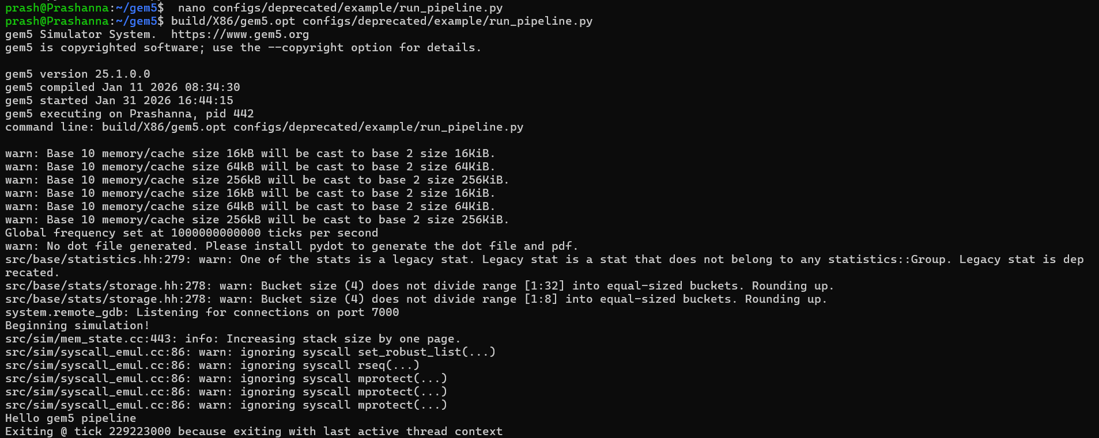
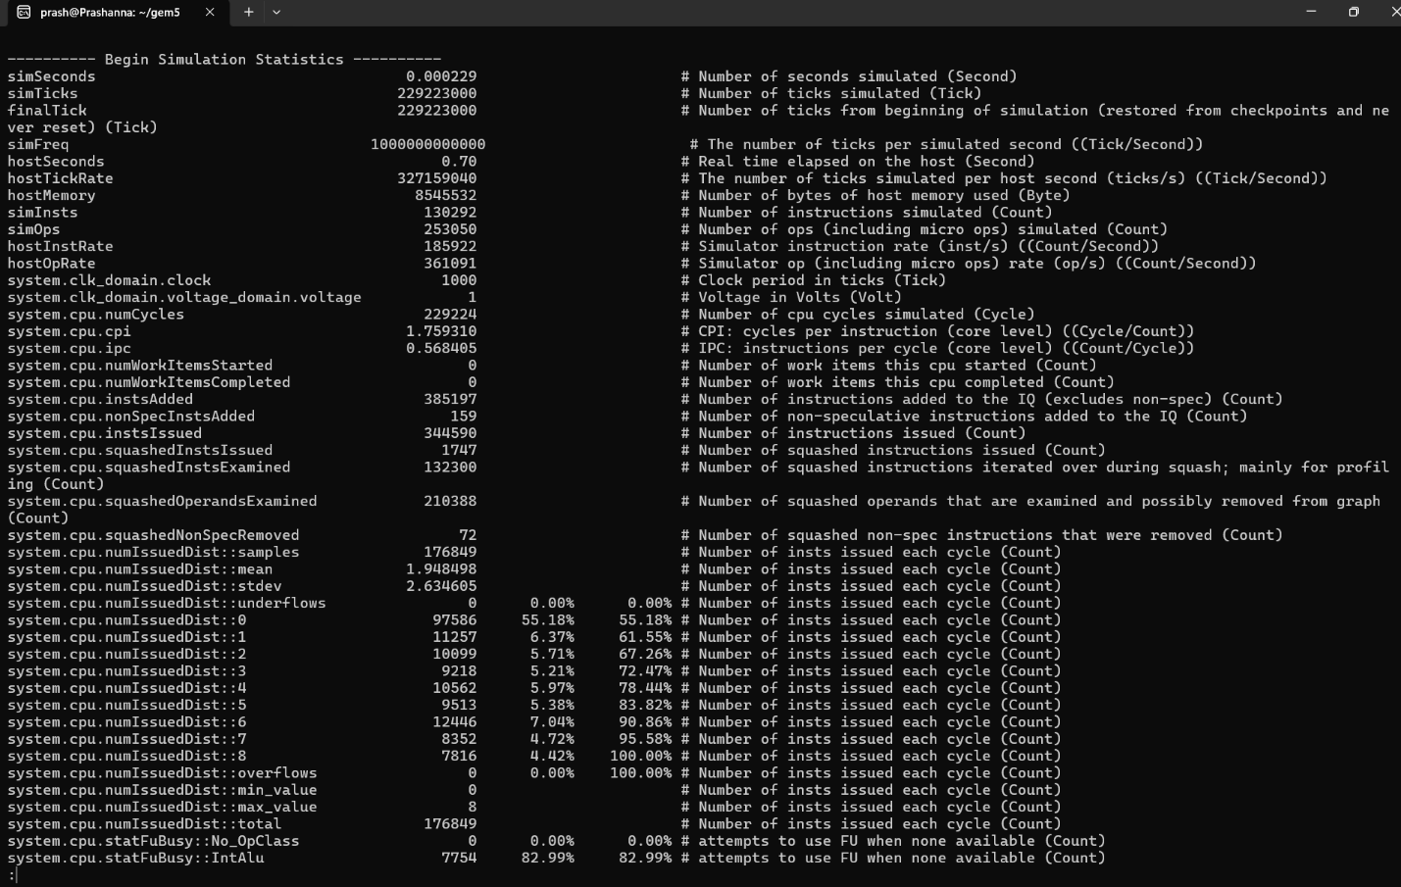
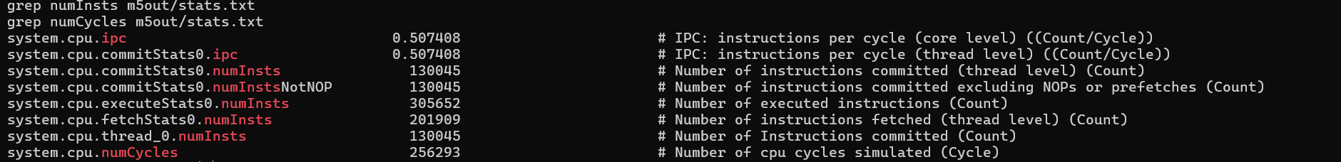
This experiment demonstrates how a pipelined processor improves performance by overlapping instruction execution across multiple stages such as fetch, decode, execute, memory, and writeback. By observing the pipeline cycle-by-cycle in gem5, it becomes clear that instruction throughput increases compared to non-pipelined execution, though stalls and hazards can limit efficiency. Collected statistics show that instruction latency is affected by control and data dependencies, while overall throughput depends on how well pipeline resources are utilized. The introduction of branch prediction further improves performance by reducing pipeline flushes caused by control hazards, highlighting the importance of accurate prediction in maintaining high instruction throughput and efficient pipeline operation.
Multiple Issues Simulator
The simulation already uses the X86O3CPU model, which is a superscalar processor. However, because the pipeline widths have not been increased, the processor is effectively operating as a single-issue CPU. In gem5’s O3 CPU model, superscalar behavior is determined by several width parameters, including fetch, decode, rename, dispatch, issue, write-back, and commit widths.
Superscalar Analysis
The superscalar configuration achieved an IPC of approximately 0.51. Although the processor is capable of issuing multiple instructions per cycle, the observed IPC is limited by the low instruction-level parallelism of the benchmark (/bin/echo), which is dominated by control flow and system calls. Pipeline hazards such as branch mispredictions and memory stalls further reduce effective utilization of multiple issue slots. Additionally, the difference between executed and committed instructions reflects speculative execution and squashed instructions, which are expected in an out-of-order superscalar design. Superscalar execution is therefore expected to provide greater performance improvements for compute-intensive workloads with higher ILP.
Multithreading
During the implementation of a multithreaded O3 pipeline in gem5 25.1, multiple runtime and configuration errors were encountered due to incompatibilities between deprecated configuration scripts and the current gem5 API. Recent versions of gem5 require explicit specification of cache timing parameters, interrupt controllers, and workloads, which older scripts assume implicitly. This resulted in repeated errors related to cache proxies, missing workloads, and uninitialized interrupt ports.
Additionally, true multithreaded execution in O3CPU is tightly constrained in syscall-emulation mode, leading to assertion failures when multiple threads were configured. Overall, the issues highlight significant API changes and stricter validation in modern gem5, making deprecated examples unsuitable for multithreaded pipeline experiments.
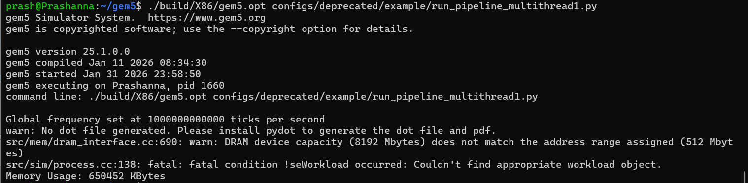
Theoretically, SMT increases overall throughput by allowing multiple threads to share the pipeline and functional units, improving utilization during stalls. However, contention for registers, issue queues, and execution units can become bottlenecks, limiting gains. Performance improves when threads have complementary resource demands rather than competing heavily for the same resources.

References
Abu-Ghazaleh, N., Ponomarev, D., & Evtyushkin, D. (2020). Architectural support for mitigating speculative execution side-channel attacks. IEEE Micro, 40(2), 68–77. https://doi.org/10.1109/MM.2020.2974842
Binkert, N., Beckmann, B., Black, G., Reinhardt, S. K., & Saidi, A. (2021). The limits of instruction-level parallelism revisited. ACM Transactions on Architecture and Code Optimization, 18(4), Article 45. https://doi.org/10.1145/3476981
Carlini, N., Kocher, P., & Gruss, D. (2021). Spectre and the limits of speculative execution. Communications of the ACM, 64(3), 64–73. https://doi.org/10.1145/3437801
Fernández, M., Ramírez, A., & Valero, M. (2022). Energy-efficient instruction scheduling in modern out-of-order processors. IEEE Transactions on Computers, 71(9), 2134–2147. https://doi.org/10.1109/TC.2021.3128324

